Lab 3 Report - Queues

**Procedure**

For this lab, we built on our progress in Lab 2. We had to implement a UART interface, to communicate with PuTTY. Using the textbook and the UART lab from Microcontrollers, we wrote some functions for the UART. The setup for the interface included enabling the HSI clock, changing the output speed, the BRR register to 1667 (to set the Baud rate at 9600), setting the data to 8 bits, with 1 stop bit, no parity bit, and enabling the NVIC interrupt.

We had to change our global variables to queues. This process involved making a global queue handle. Then we had to use queue.h with xQueueSendToBack and xQueueReceive functions. While trying to setup the queue our board would turn on the led randomly and after a short random period of time the button would stop working. We talked to the profesor and changed our task size to 64 instead of 10. Changing the task size fixed the problem and the code worked as expected.

**Results**

The results of this lab were to turn on the speaker with the button then using uart we changed the note to play a song. The UART took a while to setup and get working. We changed about everything we could think of, and quadruple checked our work. We finally got it working by changing the values of the MODE registers, they were not correct at first. The notes first sounded a bit flat, so we changed the pre-scaler to 3 and recalculated the ARR values to get the notes closer to the expected range. The waveforms were a bit fuzzy occasionally on the oscilloscope, which we expect is because of the potentiometer (the soldering isn’t great).

**Figures**

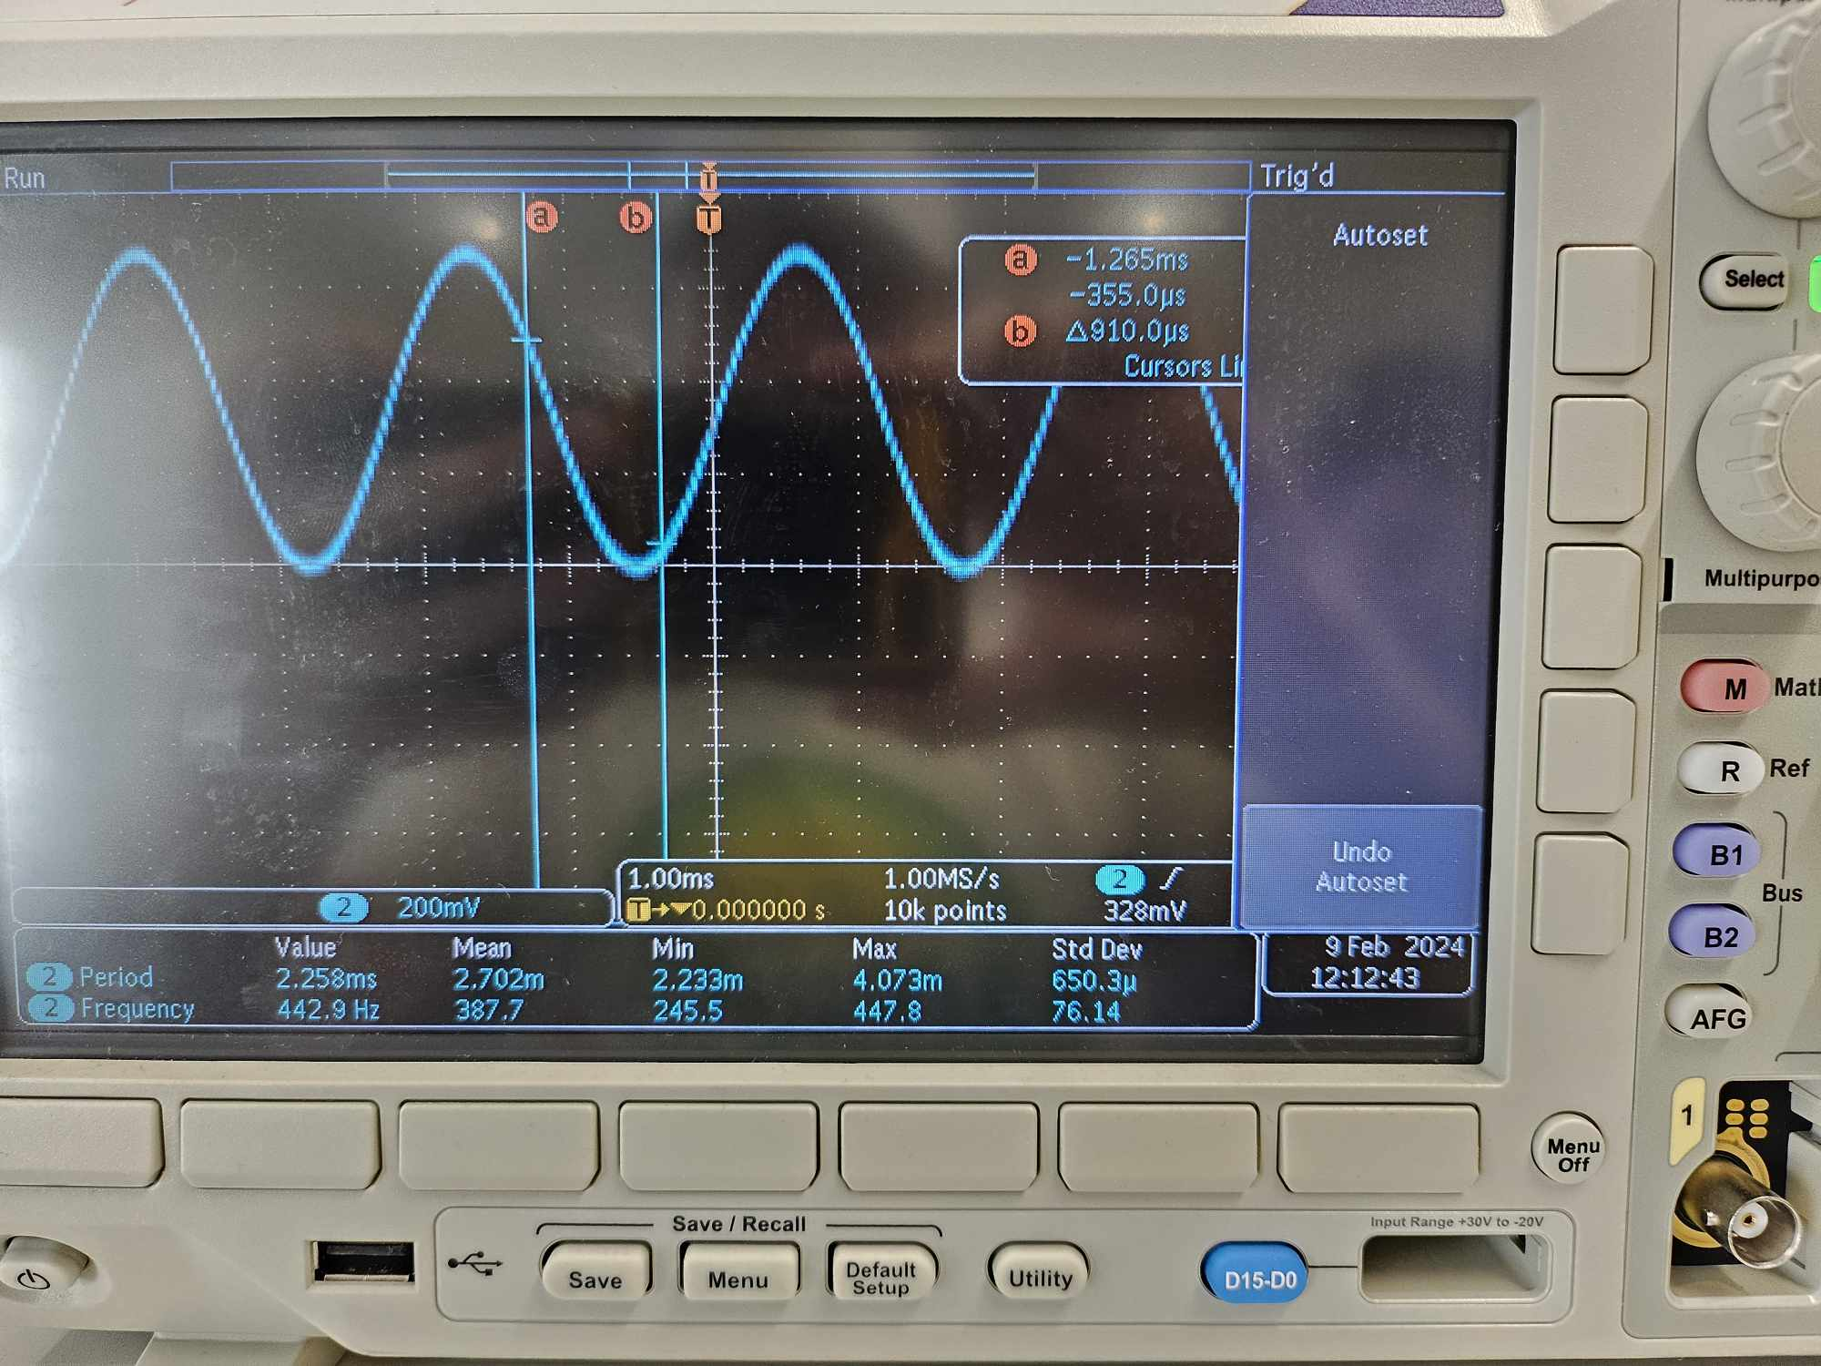

Figure 1. Sine wave on oscilloscope

**Conclusion**

In conclusion, we were able to get the UART interface working properly with queues. When we push the user button the LED turns on and the speaker plays a 220hz sound. We can then type the letters a through g in the putty terminal and it will change the note. Using a prescaler of 3 allowed us to get a more accurate sound for each note.